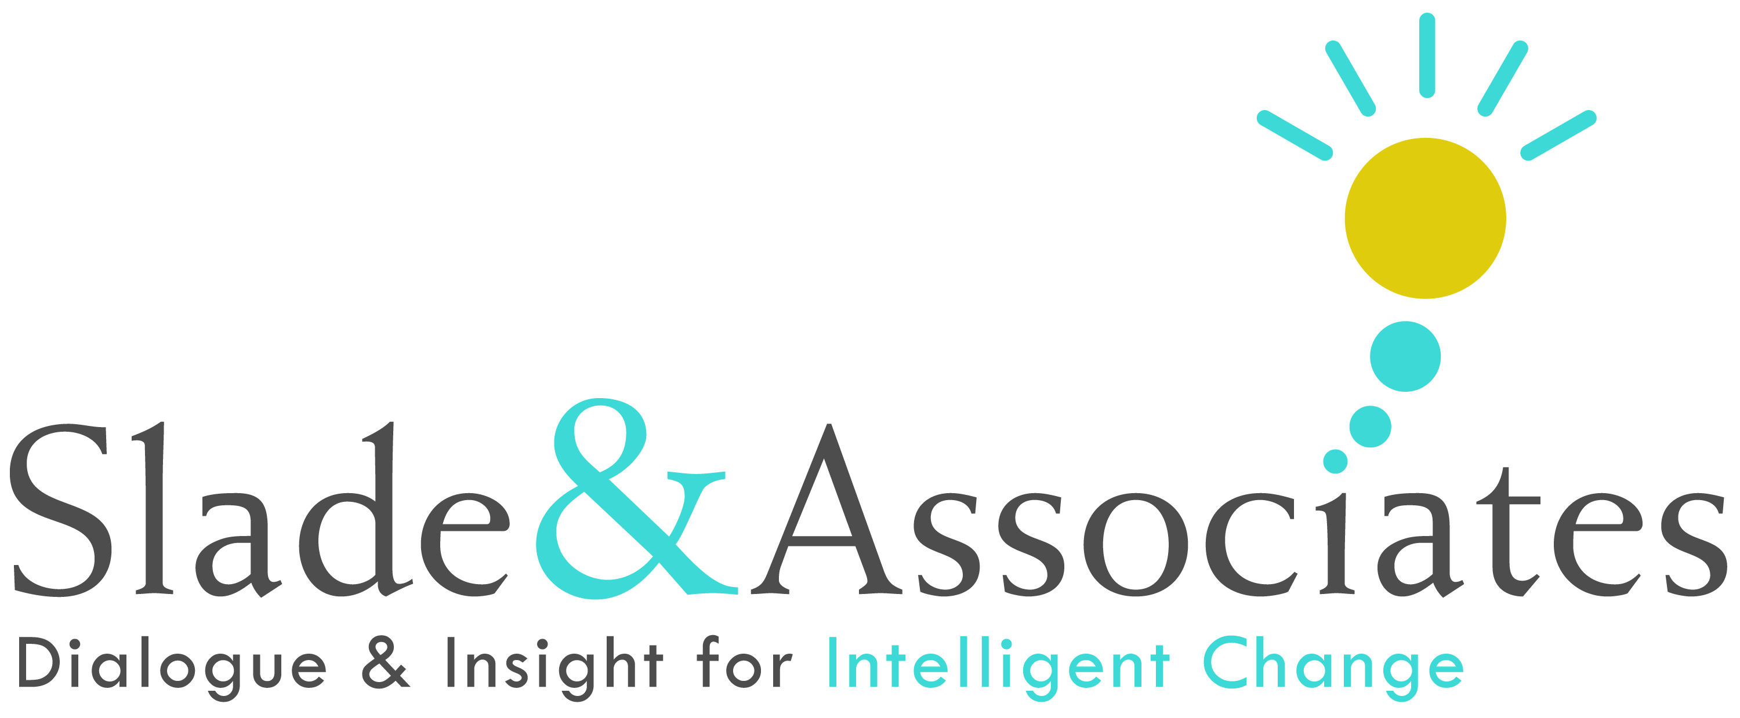

Sample Career Coaching Agreement

Client: Date:

Client’s Organization: Coach:

Purpose

I, Allen Slade, am offering this agreement to provide career coaching for the client, _________.

My Philosophy of Coaching

Career coaching supports leaders in achieving the results that are important to his or her personal success and the long term success of his or her organization. I assume that my client is the expert on his or her own career. My role as a coach is to draw out the client’s expertise through inquiry, curiosity and gentle challenges. I help the client to stretch into his or her best self. To do that, I introduce self-observation exercises and behavioral practices. I am attentive to my client’s physical, emotional, cognitive and spiritual state. I help the client to focus on his or her presence and behaviors. My role as a coach is distinct from consulting, advising, therapy, or counseling. However, coaching does address personal issues or life conditions that impact a client’s professional effectiveness.

Outcomes

The anticipated outcomes of career coaching for the client include:
- Identification of the key behaviors to continue, do more, do less, start and stop doing to increase career effectiveness. This may include job search strategies or business plan development, as requested.
- With sufficient client commitment to the process, improvement will be noticeable and measurable on specific career behaviors.
- Long term effectiveness for the client, based on increased capacity to achieve results through building and maintaining healthy relationships.

Coaching Method

My approach to career coaching includes the following:
- Determine client’s commitment to the coaching process: to solicit feedback, assess feedback, work to develop more effective behaviors, involve stakeholders to support desired changes, and measure the results of the behavior change effort.
- Identify with the client the high leverage behaviors to focus on that will provide the most strategic benefit for the client.
- Partner with the client in understanding and responding to feedback.
- Support the client in engaging more productively in career activities.
- Conduct regularly scheduled coaching sessions in person or by phone, on average once a week.
- Follow-up assessments to measure the client’s improvement.

Confidentiality

Coaching is based on confidentiality. Confidentiality is essential to building the trust needed for an effective working relationship between the client and the coach.
The client will have sole discretion to share or not share feedback assessments, the content of coaching conversations and any other information from the coaching process.
- As part of this contract, the client agrees to allow me to use the client’s name and contact information as part of the International Coach Federation (ICF) certification process. I will provide only the client’s name and contact information to the ICF, but no information on the nature of the coaching discussions.

Duration and Investment

The duration for this coaching engagement is three months. Included are 10 coaching sessions of approximately one hour each, including simulation sessions. As requested, review of resume or business plans will be provided. The coach shall be paid for____ for his services.

This coaching engagement may be extended or shortened by either the client or the coach with notice of one week, with a proportional change in professional fees.

A monthly bill will be presented to the client covering professional fees and other expenses. If other expenses are incurred by the coach (e.g., assessment expenses or transportation, meals, lodging, travel, business entertainment, equipment and supplies), the monthly will include statements, receipts or other supporting documentation as may be reasonably required. Payment will be expected on the closest business day to the middle of each month during the engagement.

Agreement

__________________________________ _______________________
Client Date

__________________________________ _______________________
Coach Date

Copyright © 2012 Slade & Associates

