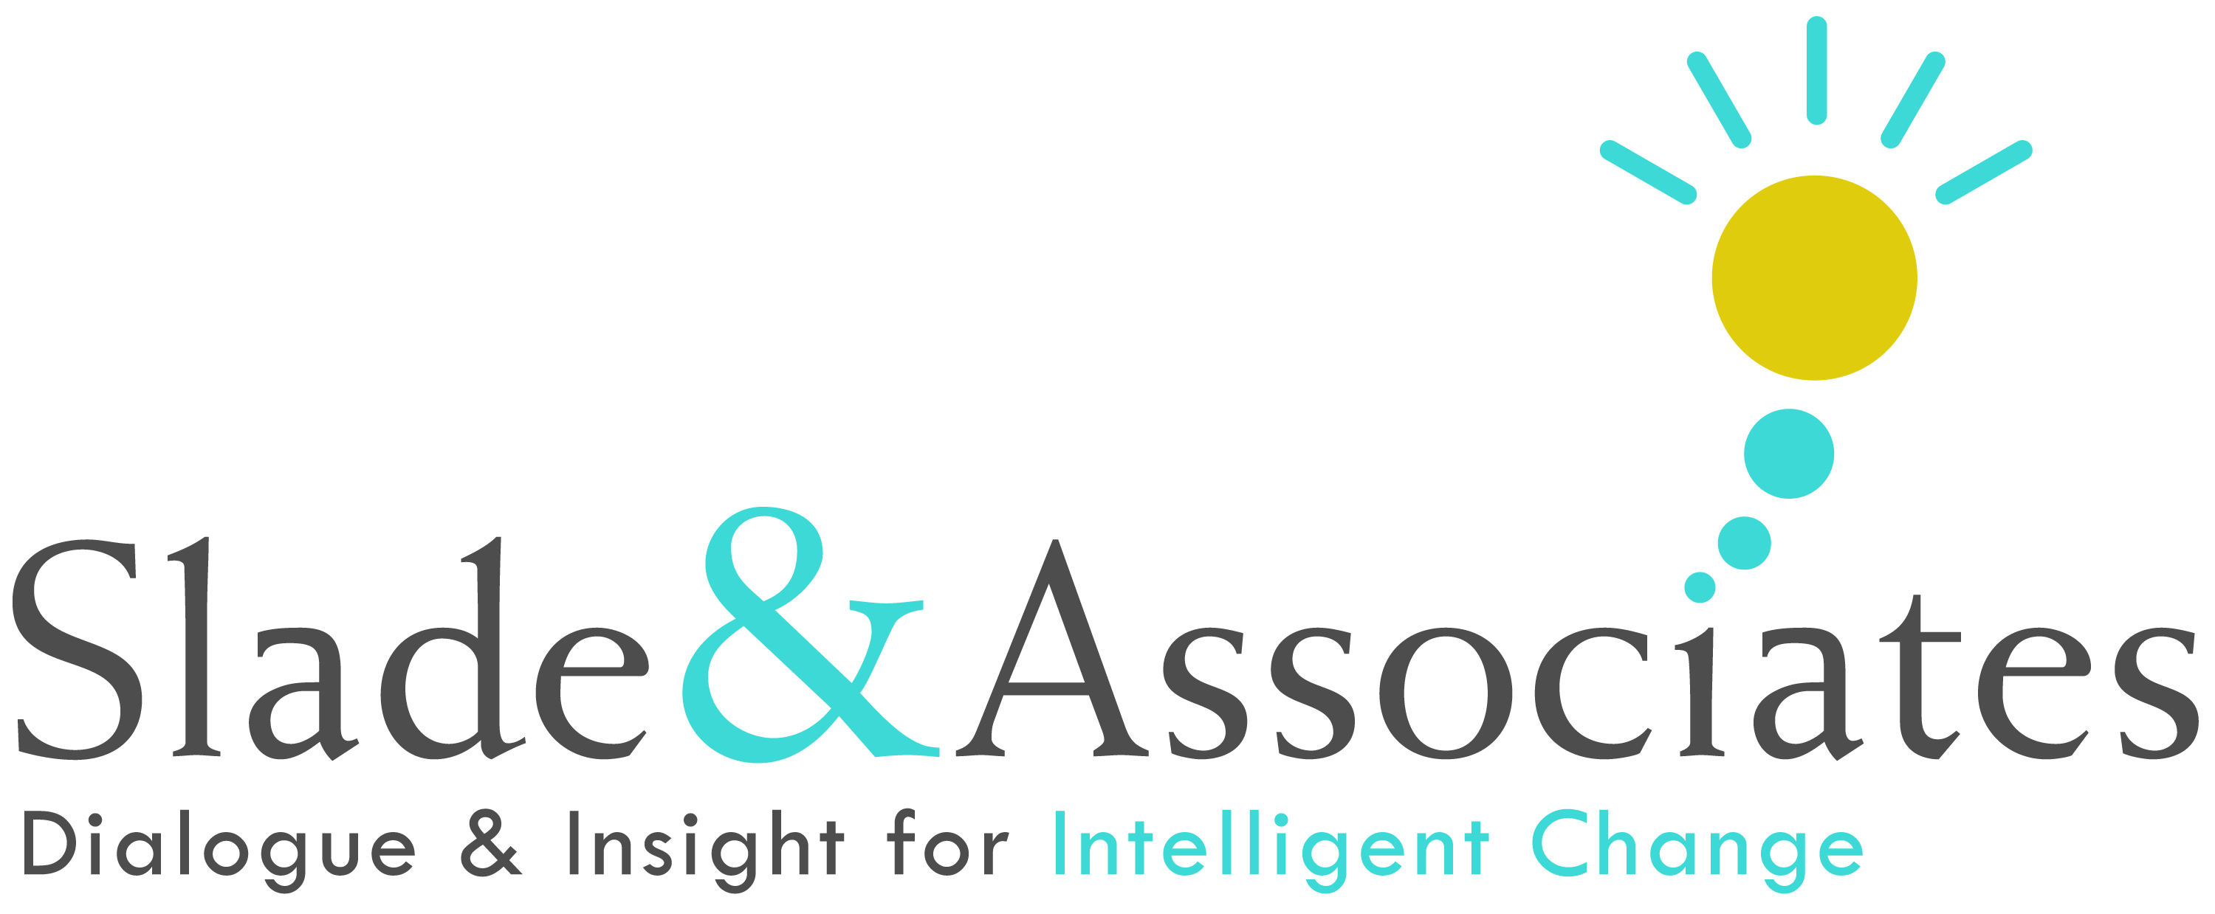

Sample Leadership Coaching Agreement

Client: Date:

Client Organization: Coach:

Purpose

I, Allen Slade, am offering this agreement to provide leadership coaching for the client, ________________.

My Philosophy of Coaching

Leadership coaching supports leaders in achieving the results that are important to his or her personal success and the long term success of his or her organization. I assume that my client is the expert on his or her own leadership. My role as a coach is to draw out the client’s expertise through inquiry, curiosity and gentle challenges. I help the client to stretch into his or her best self as a leader. To do that, I introduce self-observation exercises and behavioral practices. I am attentive to my client’s physical, emotional, cognitive and spiritual state. I help the client to focus on his or her presence and behaviors. I seek mutual understanding of the organizational culture and systems (including policies and practices) within which the client leads. My role as a coach is distinct from consulting, advising, therapy, or counseling. However, coaching does address personal issues or life conditions that impact a leader’s professional effectiveness.

Outcomes

The anticipated outcomes of leadership coaching for the client include:
- Identification of the key behaviors to continue, do more, do less, start and stop doing to increase leadership effectiveness.
- Involvement and commitment of stakeholders (i.e., direct reports, peers, support staff, supervisor) in the process of increasing effectiveness.
- With sufficient client commitment to the process, measurable improvement will be noticeable and measurable (by ongoing feedback from stakeholders) on specific leadership behaviors.
- Long term effectiveness for the client and the client organization, based on increased capacity to achieve results through building and maintaining healthy relationships.
Confidentiality
Coaching is based on confidentiality. Confidentiality is essential to building the trust needed for an effective working relationship between the client and the coach.
The client will have sole discretion to share or not share feedback assessments, the content of coaching conversations and any other information from the coaching process. I will encourage the client to be open with his or her manager regarding progress. I will also, when appropriate and with the client’s agreement, suggest conversations between the client and the client’s manager or other parties to assess progress and identify supportive next steps.
- As part of this contract, the client agrees to allow me to use the client’s name and contact information as part of the International Coach Federation (ICF) certification process. I will provide only the client’s name and contact information to the ICF, but no information on the nature of the coaching discussions.

Coaching Method

My approach to leadership coaching includes the following:
- Determine client’s commitment to the coaching process: to solicit feedback, assess feedback, work to develop more effective behaviors, involve stakeholders to support desired changes, and measure the results of the behavior change effort.
- Hold confidential interviews with stakeholders to determine behaviors the client should continue, do more, do less, start, and stop doing to be a more effective leader.
- Report to the client on the results of stakeholder interviews.
- Identify with the client the high leverage behaviors to focus on that will provide the most strategic benefit for the client and the organization.
- Partner with the client in understanding and responding to feedback.
- Support the client in engaging more productively with stakeholders.
- Conduct regularly scheduled coaching sessions in person or by phone, on average once a week.
- Follow-up assessments with key stakeholders to measure the client’s improvement.

Duration and Investment

The duration for this coaching engagement is 25 sessions of approximately one hour each over a period of 6 months.

Additional fees may be charged in some situations:
- Fee-based assessments (such as a 360 survey or leadership style inventory).
As far as possible, we will use assessments that have already been completed by the client, such as recent performance reviews, 360 surveys, leadership style inventories, personality tests and employee opinion survey results related to the client’s leadership.
- Reasonable travel expenses if the coach travels more than 30 miles to visit the client.

These coaching services are offered on a professional basis for a fee of _______________. Fees will be billed monthly, payable 30 days net.

Agreement

__________________________________ _______________________
Client Date

__________________________________ _______________________
Coach Date
Copyright © 2012 Slade & Associates

